**Baan Invoice Print Service Installation Guide**

**1. Uninstall previous version of the tool**

- Open the Print Service SetUp Window (Program Files – Baan Invoice Print)

- Save your setting - make Print Screen of the Print Service SetUp Window

- Stop the Service – click on the “Stop Service” button in the Print Service SetUp

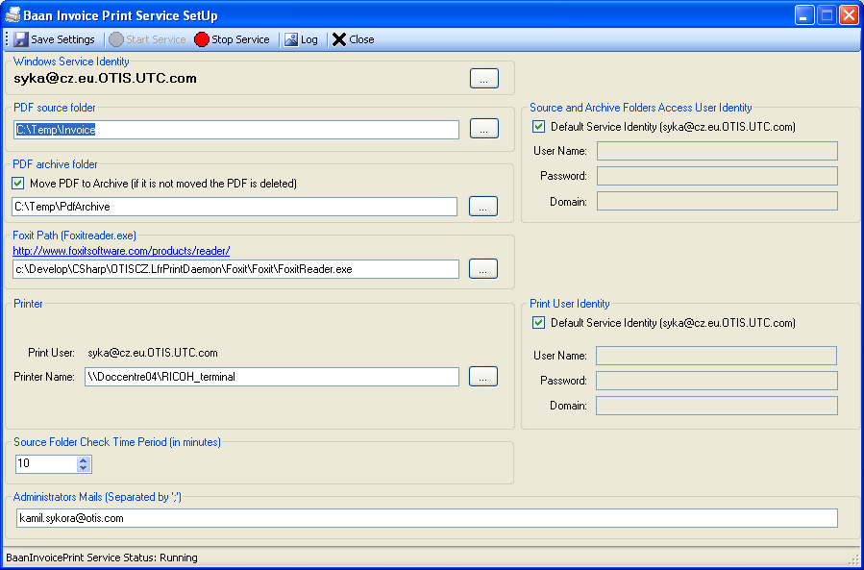

* Go to Control Panel – Add/Remove programs
* Select Baan Invoice Print - Uninstall

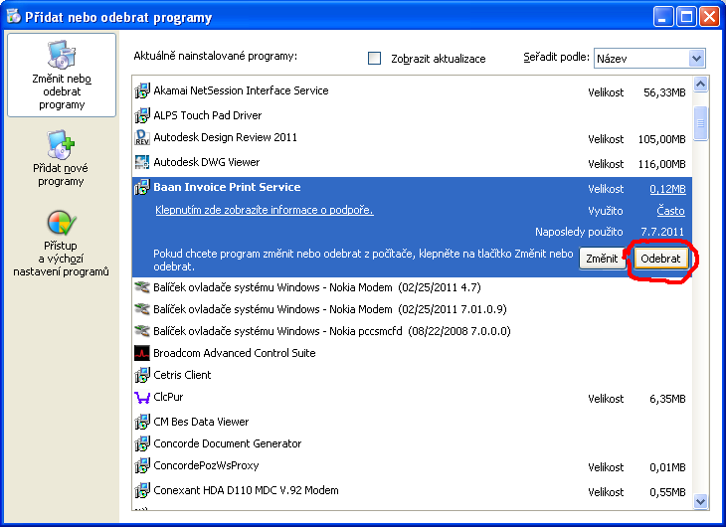

**2. Install new version**

- run the BaanPrintServiceInstaller.msi

- set the properties in the Print Service SetUp

- you can see then the service in the Services list

